Supplementary Section: Technology can sting when reality bites: Adolescents’ frequent online coping is ineffective with momentary stress. Computers in Human Behavior. Duvenage, Correia, Uink, Barber, Donovan, & Modecki
Figure 1. Study design.
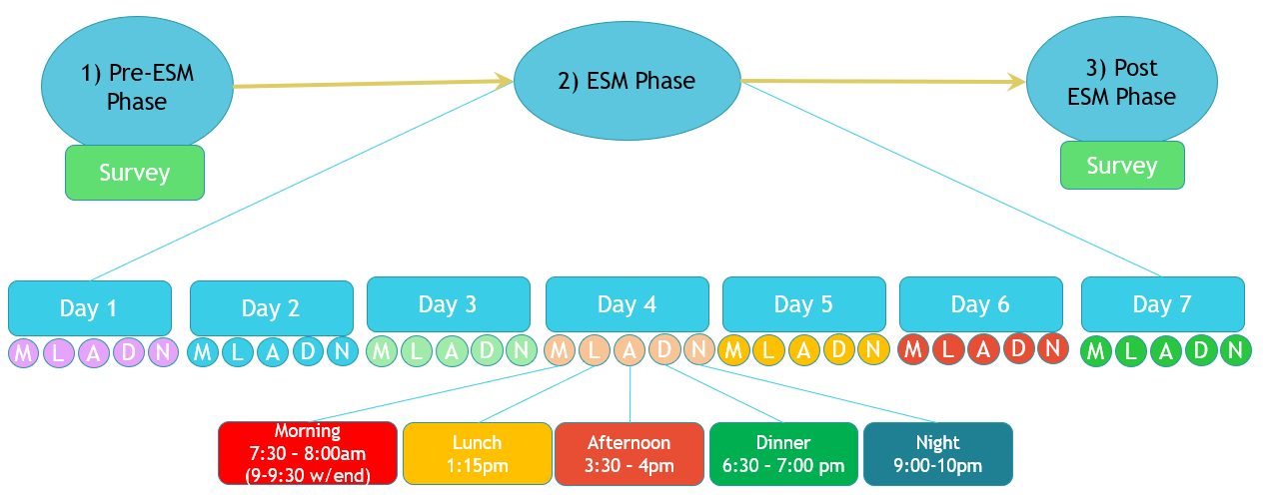

Notes. “How do you feel? Adolescent behaviour, emotion, and technology use over time;” study design, illustrating the three phases of the study: (1) a Pre-ESM assessment phase (2) an Experience Sampling Method (ESM) Study of the adolescents via mobile devices for 7 consecutive days, and (3) a Post-ESM Phase assessment.
One key element of the study was our commitment to youth participation and engagement. Research team members were available on site at each school, every day the study ran. This approach ensured regular opportunities to gain rapport with students, to encourage consistent and honest reporting, and make clear the importance of accuracy of results. In addition, research team members were on hand to troubleshoot any technical issues, and this meant availability before the start of each school day and past school closing. Further, a researcher cell-phone was monitored each day (weekends) and night (all days) of the study, in the event of any technical issues, or if there was a need to connect to additional psychological support (a psychologist was on call in the event of any issues in relation to reporting stressors).

